AI ASSISTED CODING
LAB ASSIGNMENT 3.5
T.SAI SATHWIK
2303A51221
BATCH – 04
Platform Used: Git hub co-poilot
ZERO SHOT
ONE SHOT
FEW SHOT
Question 1: Zero-Shot Prompting (Leap Year Check)
Write a zero-shot prompt to generate a Python function that checks
whether a given year is a leap year.
Task:
• Record the AI-generated code.
• Test with years like 1900, 2000, 2024.
• Identify logical flaws or missing conditions.
PROMPT
Write a Python function that checks whether a given year is a leap year.
The function should return True if it is a leap year and False otherwise.
CODE
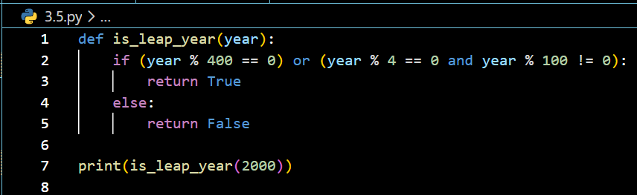

OUTPUT
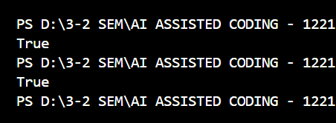
EXPLANATION
A leap year is divisible by 400, or divisible by 4 but not by 100.
The function checks these conditions and returns the appropriate boolean value.

Question 2: One-Shot Prompting (GCD of Two Numbers)
Write a one-shot prompt with one example to generate a Python
function that finds the Greatest Common Divisor (GCD) of two numbers.
Example:
Input: 12, 18 → Output: 6
Task:
• Compare with a zero-shot solution.
• Analyze algorithm efficiency
PROMPT
Write a Python function to find the Greatest Common Divisor (GCD) of two numbers.
Example:
Input: 12, 18
Output: 6

CODE
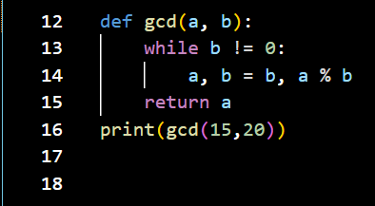
OUTPUT
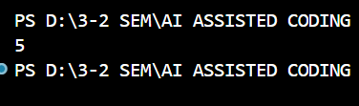
EXPLANATION
This function uses the Euclidean Algorithm, which repeatedly replaces the larger number with the remainder until the remainder becomes zero.
The last non-zero value is the GCD.

Question 3: Few-Shot Prompting (LCM Calculation)
Write a few-shot prompt with multiple examples to generate a Python
function that computes the Least Common Multiple (LCM).
Examples:
• Input: 4, 6 → Output: 12
• Input: 5, 10 → Output: 10
• Input: 7, 3 → Output: 21
Task:
• Examine how examples guide formula selection.
• Test edge cases.

PROMPT
Write a Python function to compute the Least Common Multiple (LCM) of two numbers
Examples:
Input: 4, 6 → Output: 12
Input: 5, 10 → Output: 10
Input: 7, 3 → Output: 21

CODE
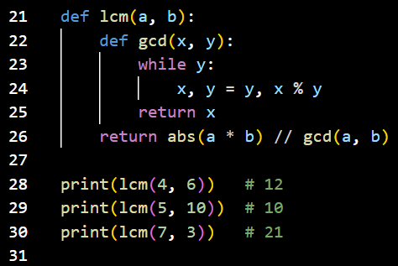
OUTPUT
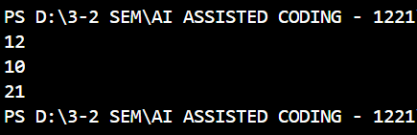
EXPLANATION
LCM is calculated using the formula:
LCM(a, b) = (a × b) / GCD(a, b).
The examples guide the AI to choose this mathematical formula.

Question 4: Zero-Shot Prompting (Binary to Decimal Conversion)
Write a zero-shot prompt to generate a Python function that converts a
binary number to decimal.

Task:
• Test with valid and invalid binary inputs.
• Identify missing validation logic.
PROMPT
Write a Python function that converts a binary number into its decimal equivalent.
CODE
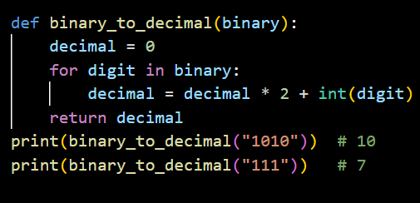
OUTPUT
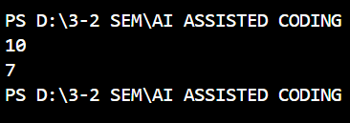
EXPLANATION
Each binary digit is processed from left to right.
The current value is multiplied by 2 and the digit is added, converting binary to decimal.

Question 5: One-Shot Prompting (Decimal to Binary Conversion)
Write a one-shot prompt with an example to generate a Python function
that converts a decimal number to binary.
Example:
Input: 10 → Output: 1010
Task:
• Compare clarity with zero-shot output.
• Analyze handling of zero and negative numbers.

PROMPT
Write a Python function to convert a decimal number to binary.
Example:
Input: 10
Output: 1010
CODE
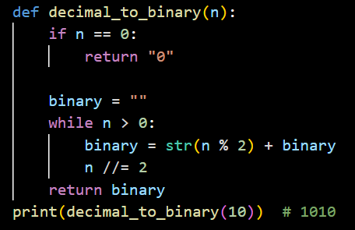
OUTPUT
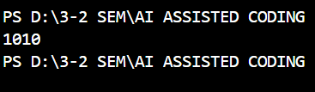

EXPLANATION
The decimal number is repeatedly divided by 2.
The remainders are collected in reverse order to form the binary representation.

Question 6: Few-Shot Prompting (Harshad Number Check)
Write a few-shot prompt to generate a Python function that checks
whether a number is a Harshad (Niven) number.
Examples:
• Input: 18 → Output: Harshad Number
• Input: 21 → Output: Harshad Number
• Input: 19 → Output: Not a Harshad Number
Task:
• Test boundary conditions.
• Evaluate robustness
PROMPT
Write a Python function to check whether a number is a Harshad (Niven) number.
Examples:
Input: 18 → Output: Harshad Number
Input: 21 → Output: Harshad Number
Input: 19 → Output: Not a Harshad Number
CODE
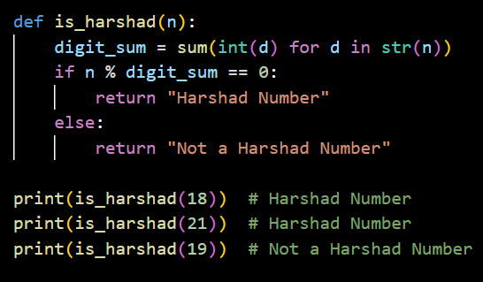

OUTPUT
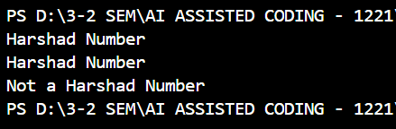
EXPLANATION
A Harshad number is divisible by the sum of its digits.
The function calculates the digit sum and checks divisibility.

